Lab 03 - NAND Only Logic
In this lab, you’ve learned how to convert arbitrary logical equations into NAND only circuits, and why that might be a good thing.

Rubric

Item | Description | Value
Summary Answers | Your writings about what you learned in this lab. | 25%
Question 1 | Your answers to the question | 25%
Question 2 | Your answers to the question | 25%
Question 3 | Your answers to the question | 25%

Lab Summary
Summarize your learnings from the lab here.
I learned how to use that breadboard thing. Very interesting way to see circuits.

Lab Questions

1 - Write down DeMorgan’s Law and the truth tables proving it out.
If A AND B are both needed for success, and the success it NOT met, then it means either
A failed OR B failed
If either A or B need to be successful to meet the success condition, then failure implies
that both A failed AND B failed individually

A | B | C | D | A.B’ | C.D | F
0 | 0 | 0 | 0 | 0 | 0 | 0
0 | 0 | 0 | 1 | 0 | 0 | 0
0 | 0 | 1 | 0 | 0 | 0 | 0
0 | 0 | 1 | 1 | 0 | 1 | 1
0 | 1 | 0 | 0 | 0 | 0 | 0
0 | 1 | 0 | 1 | 0 | 0 | 0
0 | 1 | 1 | 0 | 0 | 0 | 0
0 | 1 | 1 | 1 | 0 | 1 | 1
1 | 0 | 0 | 0 | 1 | 0 | 1
1 | 0 | 0 | 1 | 1 | 0 | 1
1 | 0 | 1 | 0 | 1 | 0 | 1
1 | 0 | 1 | 1 | 1 | 1 | 1
1 | 1 | 0 | 0 | 0 | 0 | 0
1 | 1 | 0 | 1 | 0 | 0 | 0
1 | 1 | 1 | 0 | 0 | 0 | 0
1 | 1 | 1 | 1 | 0 | 1 | 1

$$F=\overline{\overline{\left(A.\left(\overline{B.B}\right)\right)}.\left(\overline{C.D}\right)}$$
This was the equation that we came up with to put onto that breadboard.

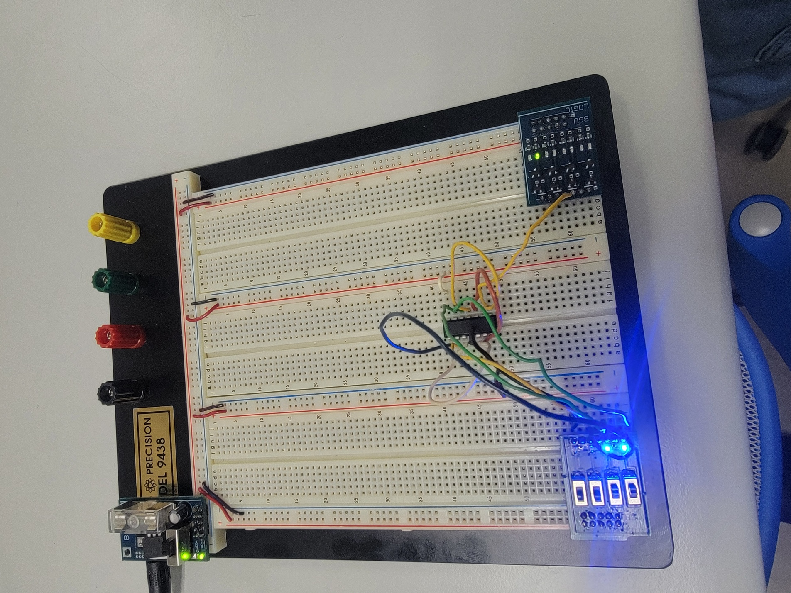

2 - What is the value in converting circuits to NAND only?
NAND is a universal gate. Any of the Boolean functions can be built from NAND gates. It probably simplifies production of chips or other circuits because you only need to create one.

3 - How does what you did in lab with the breadboard relate to the FPGA?
These lab help me to physically understand how the circuits work from the ground up so when I program or reprogram them I can have a more concrete view of how these things work. It will also help me to translate equations and truth tables to in real life circuits.

Code Submission
Upload a .zip of all your code or a public repository on GitHub.

